Application to be an Individual member
The New South Wales Council for Intellectual Disability.
 | Your name_________________________
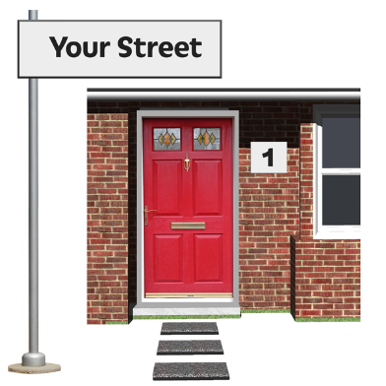 | Address __________________________  __________________________________
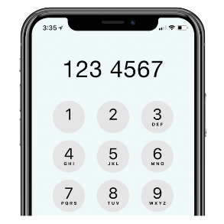 | Phone number ______________________
 | Email _______ ______________________
Membership Agreement

I have read and understood CID’s Ethical Framework and I agree to follow the Ethical Framework as a member of CID.

You can read the Ethical Framework of our website Ethical Framework - Council for Intellectual Disability (cid.org.au) or contact CID for a copy.

 | My signature ______________________
 | Date ____________________________

Membership payment
CID has different types of membership.

Tick the box next to the membership you want to apply for.

Person in paid work $35

Includes GST
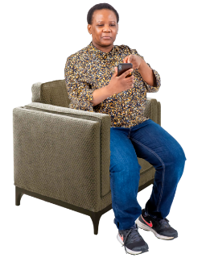 | Person not in paid work $15  Includes GST
 | Person with intellectual disability Free

This form will be a tax invoice when you make your payment.

Tick how you will pay
Online (EFY)
Pay the membership fee to
Account name NSW Council for Intellectual Disability
BSB 062 003
Account Number 10012767

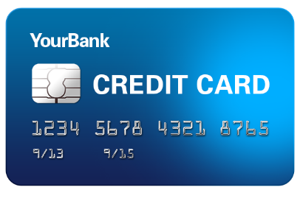 | Credit Card  When we get this form we will send an invoice to tell you how to pay by credit card
 | Email the membership form to info@cid.org.au
Post to Council for Intellectual Disability
Level 2, 418A Elizabeth St,
Surry Hills 2010
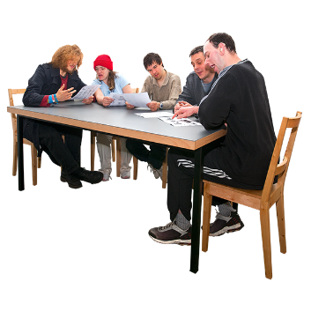 | When we get the form The Board will decide if you can be a member.  CID will tell you what the Board decides.

