How to use this sheet
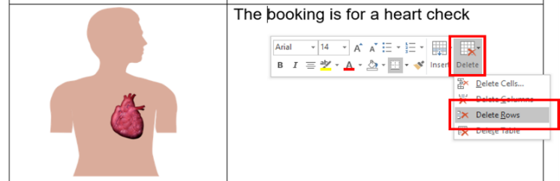
- Delete the rows you do not need (e.g. delete the ‘Heart check’ section if the appointment is not for a heart check. To delete a row:
  - Click the row you want to delete
  - Right click (or Ctrl + click on Mac) and then click ‘Delete’
  - Click ‘Delete Rows’.
- Insert relevant text where prompted. Text placeholders are marked in between brackets and in a different colour. E.g. [address].
- Instructions are marked in italics and in a different colour. E.g.
-if a large building like a hospital, or town centre, include level, clinic name-
- Add the relevant images. You can take a photo of the health professional and the person sending the letter and insert them into the document. Make sure the person being photographed is the only person in the frame. Photos taken with a mobile phone are fine.
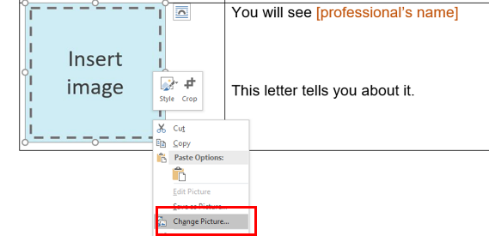
We have added image placeholders. To replace a placeholder with a new image:
  - Save the new image in your computer
  - Right click (or Ctrl + click on Mac) on the placeholder
  - Click on ‘Change Picture’
  - Select the new image.

Or simply copy the new image and paste it where the placeholder is (this may affect the document’s formatting).

- Change all font to black: Select the table cells and choose font colour – black.
- Finally, remove the table lines: Select the table cells then go to table design and select no border.

Easy Read basics

Follow these principles when tailoring and formatting the letter to ensure it is Easy Read:
- Nothing smaller than 14 point:
  - Use Arial, Verdana or Tahoma (sans serif fonts);
  - Size 14 for main text and 16 or larger for headings.
- Less is best, keep it simple:
  - Use short sentences and simple everyday words;
  - Avoid jargon, slang and technical terms;
  - Avoid unnecessary details, focus on what people need to know, not what it is nice to know.
- Ensure plenty of white space
  - Include no more than four images per page.

All the images included in this document have been purchased through stock sites and Photosymbols and cannot be reproduced, redistributed or used for any other purpose without their permission.
- - - - - - - - - - - - - - - - - - - - - - - - - - - - - - - - - - - - - - - - - - - - - - - - - - - - - - - - - - - - - - - - - - - - - - - - - - - - -

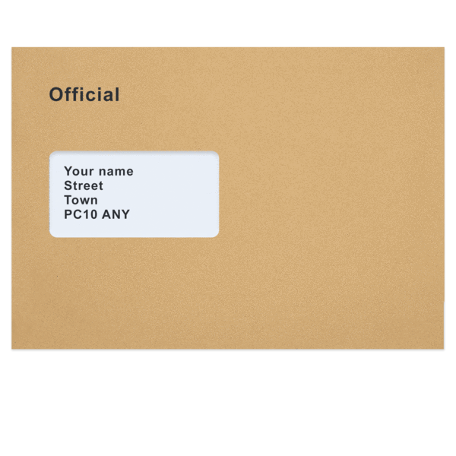 | Dear [patient name]  This letter is from [your name or the professional’s name if writing on their behalf]
 | This is a picture of [person writing the letter].
You have an appointment

This letter tells you about it.

You will see [professional name]

This is a picture of [professional name]

[professional’s name] is a [profession or doctor].

X  TYPE | Your appointment is on [date in full].
X X : X X | It is at [time].
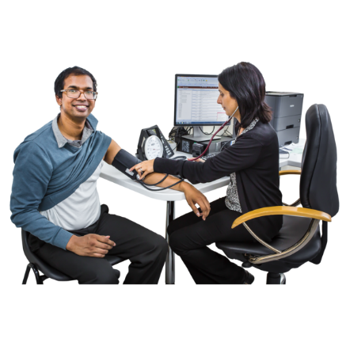 | The booking is for a health check
The booking is for an ultra sound

That is kind of scan

It will help to see what is going on

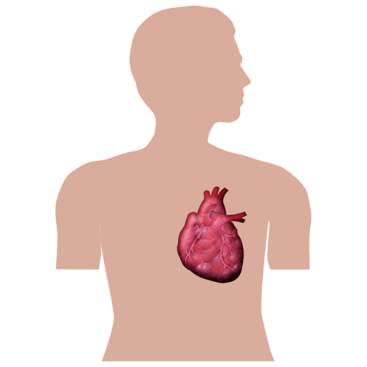 | The booking is for a heart check
The booking is to talk about
how you are going
 | The booking is to see the doctor
 | The booking is to check your stomach
 | The booking is for counselling
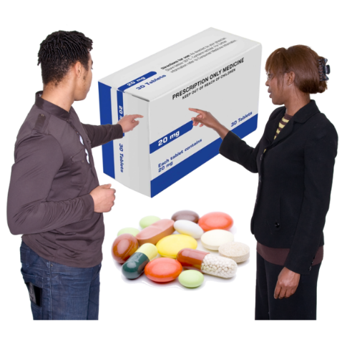 | The booking is to check your medicine
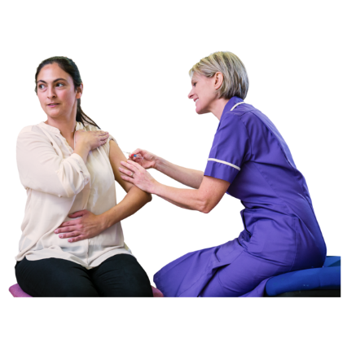 | The booking is for a vaccine
 | The booking is to talk about healthy food
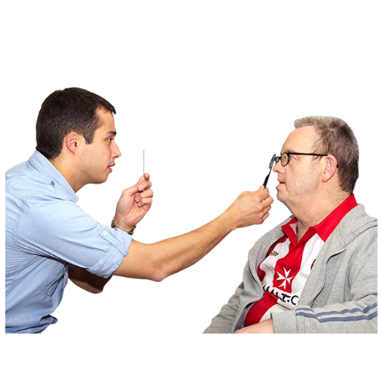 | The booking is to check your eyes
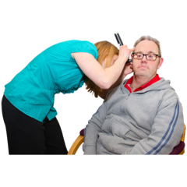 | The booking is to check your ears
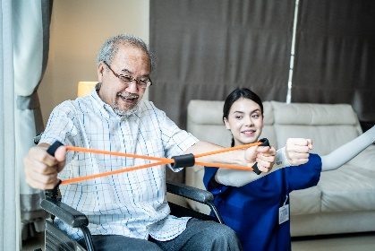 | The booking is for OT
 | The booking is for physio
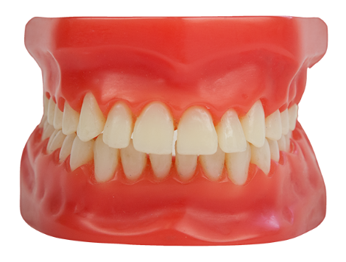 | The booking is to check your teeth
 | The booking is for dental work
 | The booking is for speech therapy

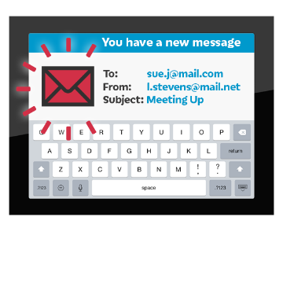 | [Professional name] will email you a link.  It will be sent on [date].
The appointment is at [address]
-if a large building like a hospital, or town centre, include level, clinic name-

This is what the building looks like.

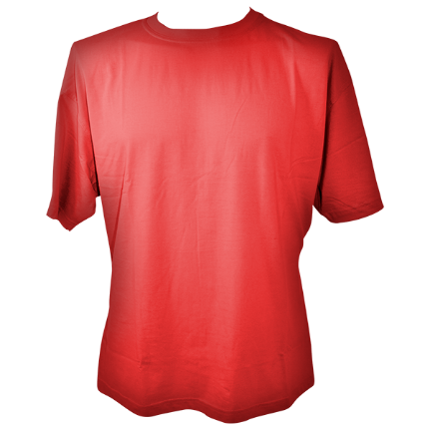 | Wear a T-shirt with short sleeves.  You can have a jumper too.

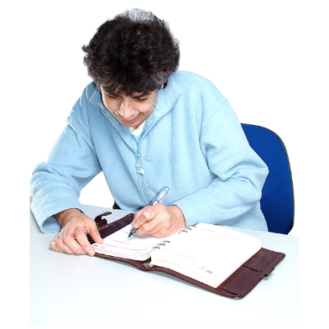 | You wrote down your appointment.  You put it in [phone calendar, in My Health Matters folder, in diary etc.]
Do you have a question?

You can call [name or clinic or just me/us] on [number]
If you need to change the time call

[name or clinic or just me/us]

on [number]
 | From [name of person sending letter]
What to bring
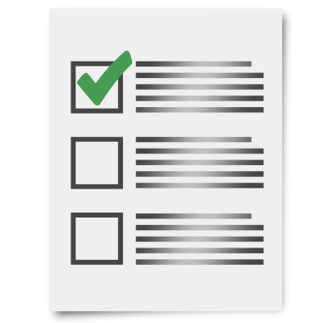 | Take these things to the appointment
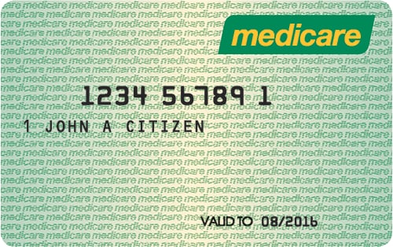 | Your Medicare card
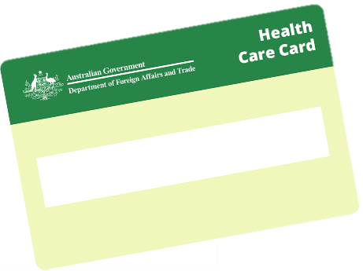 | Your Healthcare card
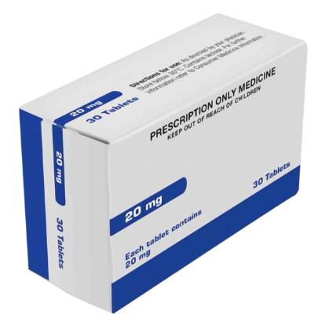 | A list of the medicine you take

 | This letter
 | Your health information
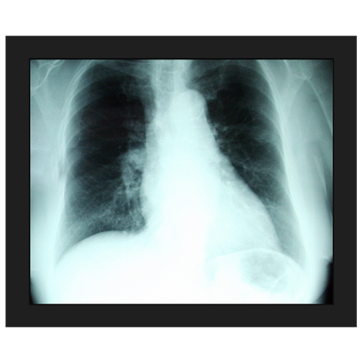 | Your X-rays
 | Your scans
 | The letter you got from [Dr. XXXXXX].

