How to use this sheet
- - - - - - - - - - - - - - - - - - - - - - - - - - - - - - - - - - - - - - - - - - - - - - - - - - - - - - - - - - - - - - - - - - - - - - - - - - - - -
- Delete the rows you do not need (e.g. delete the ‘Nearest tram stop’ section if there are no trams nearby). To delete a row:
  - Click the row you want to delete
  - Right click (or Ctrl + click on Mac) and then click ‘Delete’
  - Click ‘Delete Rows’.
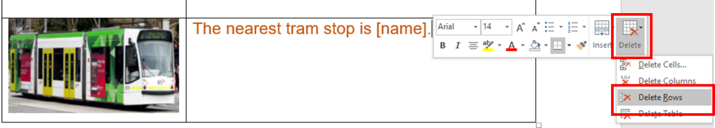
- Insert relevant text where prompted. Text placeholders are marked in between brackets and in a different colour. E.g. [address].

- Instructions are marked in italics and in a different colour. E.g.
-if a large building like a hospital, or town centre, include level, clinic name-
- Add the relevant images. You can photograph your building, along with the reception desk, and any specific points for directions as required. Photos taken with a mobile phone are fine.

We have added image placeholders. To replace a placeholder with a new image:
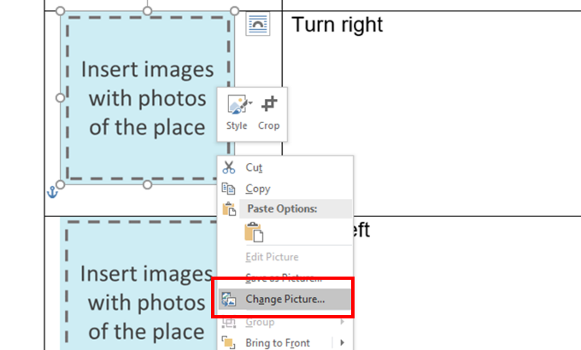
  - Save the new image in your computer
  - Right click (or Ctrl + click on Mac) on the placeholder
  - Click on ‘Change Picture’
  - Select the new image.

- Change all font to black

Select the table cells and choose font colour – black.

- Finally, remove the table lines.
Select the table cells then go to table design and select no border.

Easy Read basics

Follow these principles when tailoring and formatting the letter to ensure it is Easy Read:
- Nothing smaller than 14 point:
  - Use Arial, Verdana or Tahoma (sans serif fonts);
  - Size 14 for main text and 16 or larger for headings.
- Less is best, keep it simple:
  - Use short sentences and simple everyday words;
  - Avoid jargon, slang and technical terms;
  - Avoid unnecessary details, focus on what people need to know, not what it is nice to know.
- Ensure plenty of white space
  - Include no more than four images per page.

All the images included in this document have been purchased through stock sites and Photosymbols and cannot be reproduced, redistributed or used for any other purpose without their permission.

* The images included in this document have been purchased through stock sites and Photosymbols and cannot be reproduced, redistributed or used for any other purpose without their permission.
- - - - - - - - - - - - - - - - - - - - - - - - - - - - - - - - - - - - - - - - - - - - - - - - - - - - - - - - - - - - - - - - - - - - - - - - - - - - -
How to get to [clinic/address/our place]

The appointment is at [address]
-if a large building like a hospital, or town centre, include level, clinic name-

This is what the building looks like.
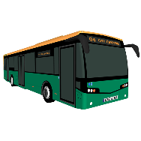 | The nearest bus stop is at [address]
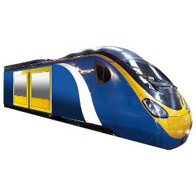 | The nearest train station is [name].
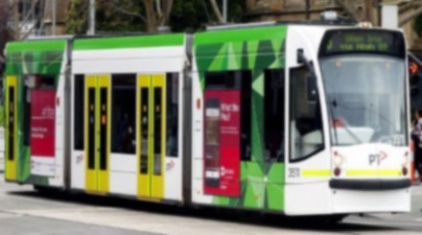 | The nearest tram stop is [name].

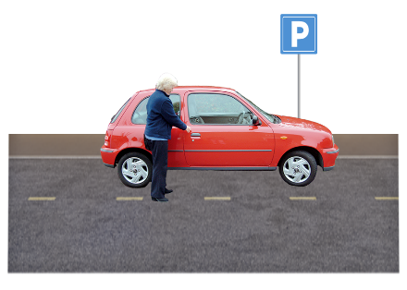 | You can park on the street.
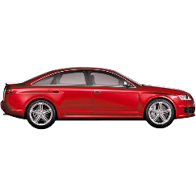 | You can park in a car park.  There is one at [address]
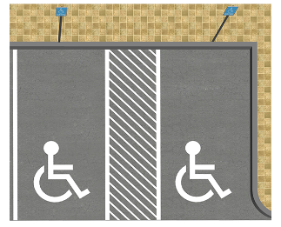 | There is disability parking [at our clinic; on the street outside; in the car park].  If you have a permit you can park in that spot.

Once you arrive
The appointment is at [hospital or centre name]
-if a large building like a hospital, or town centre, include level, clinic name-
If not needed - delete
This is what the building looks like.
Go in from [street name]
Delete if not needed

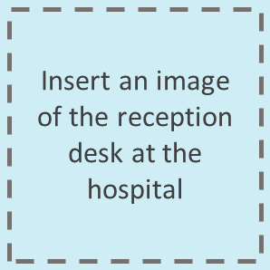 | Talk to the people at the desk.  Tell them you need to get to [clinic name].  Ask them to take you there.
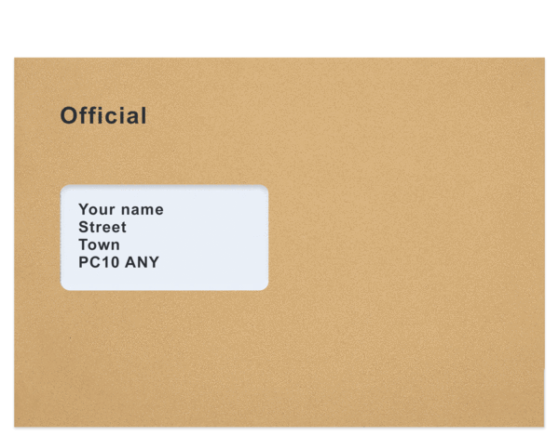 | You can show them this letter.

Go to the end of the corridor
Turn right
Turn left
Take the lift to level X.
This is what our clinic door looks like.

