How to use this sheet
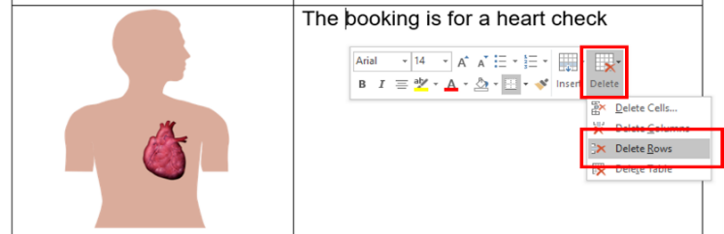
- Delete the rows you do not need (e.g. delete the ‘Heart check’ section if the appointment is not for a heart check. To delete a row:
  - Click the row you want to delete
  - Right click (or Ctrl + click on Mac) and then click ‘Delete’
  - Click ‘Delete Rows’.
- Insert relevant text where prompted. Text placeholders are marked in between brackets and in a different colour. E.g. [date].

- Add the relevant images. You can take a photo of the health professional and the person sending the letter and insert them into the document. Make sure the person being photographed is the only person in the frame. Photos taken with a mobile phone are fine.
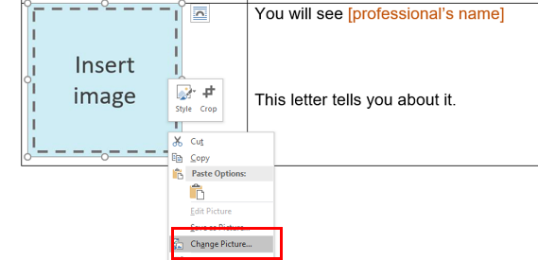
We have added image placeholders. To replace a placeholder with a new image:
  - Save the new image in your computer
  - Right click (or Ctrl + click on Mac) on the placeholder
  - Click on ‘Change Picture’
  - Select the new image.

Or simply copy the new image and paste it where the placeholder is (this may affect the document’s formatting).

- Change all font to black: Select the table cells and choose font colour – black.
- Finally, remove the table lines: Select the table cells then go to table design and select no border.

Easy Read basics

Follow these principles when tailoring and formatting the letter to ensure it is Easy Read:
- Nothing smaller than 14 point:
  - Use Arial, Verdana or Tahoma (sans serif fonts);
  - Size 14 for main text and 16 or larger for headings.
- Less is best, keep it simple:
  - Use short sentences and simple everyday words;
  - Avoid jargon, slang and technical terms;
  - Avoid unnecessary details, focus on what people need to know, not what it is nice to know.
- Ensure plenty of white space
  - Include no more than four images per page.

The Council for Intellectual Disability made the original version of this document. CID for short.
You can use the pictures to make letters.
But you need to ask CID if you want to use any of the pictures for other reasons. Contact CID at business@cid.org.au.
- - - - - - - - - - - - - - - - - - - - - - - - - - - - - - - - - - - - - - - - - - - - - - - - - - - - - - - - - - - - - - - - - - - - - - - - - - - -

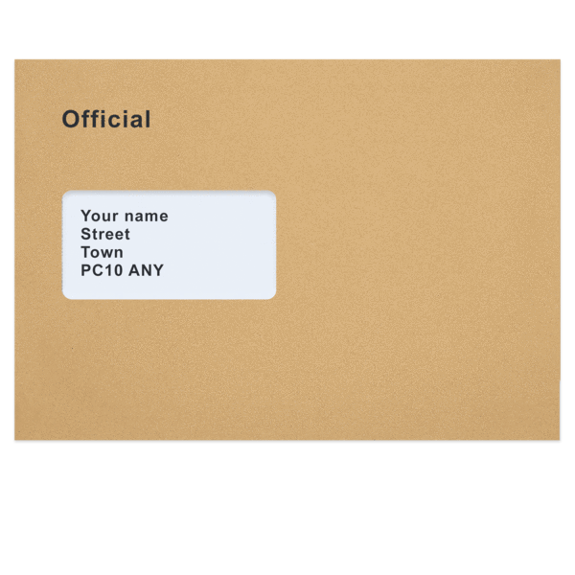 | Dear [patient name]  This letter is from [your name or the professional’s name if writing on their behalf]
 | This is a picture of [person writing the letter].
You have an appointment

This letter tells you about it.

You will see [professional name]

This is a picture of [professional name]

[professional’s name] is a [profession or doctor].

X  TYPE | Your appointment is on [date in full].
X X : X X | It is at [time].
Your appointment is virtual.

Virtual appointment is when you speak
with [Professional name] online.
You will need a device for the appointment.

A device can be a
- computer
- tablet
or
- phone.
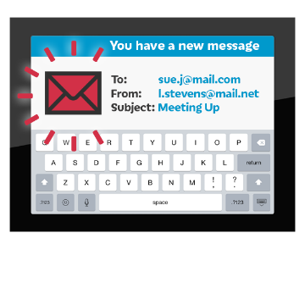 | [Professional name] will send you an email.  It will include:  - Link  - User name  - Password  - [other]
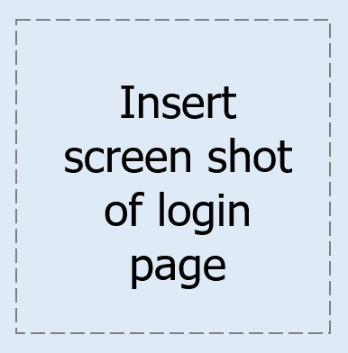 | When you click on the link  you will see this page.  Enter user name and password.
 | Make sure your microphone works.
 | Make sure you camera works.
If it does not work
you can call [Professional name]
on [phone number].
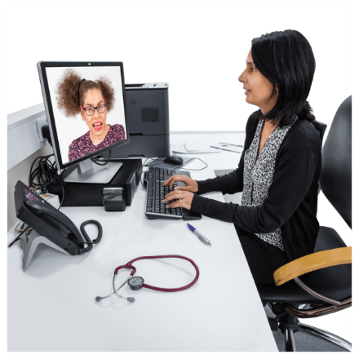 | The appointment is to talk about  how you are going
 | The appointment is for counselling
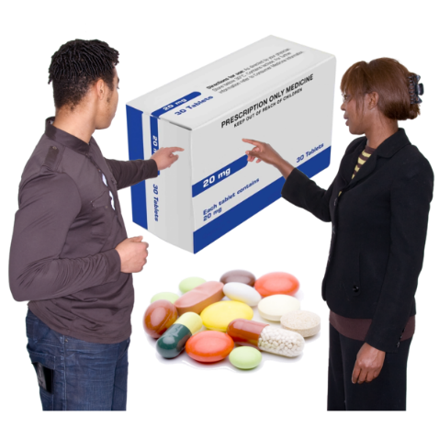 | The appointment is to check your medicine
 | The appointment is to talk about healthy food
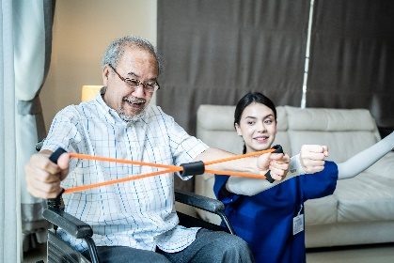 | The appointment is for OT
 | The appointment is for physio
 | The appointment is for speech therapy

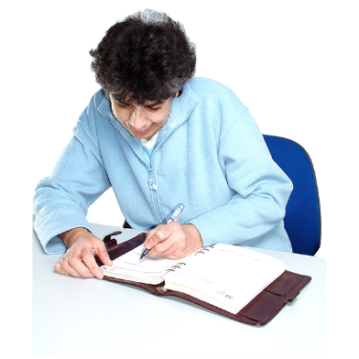 | Write down your appointment.  You can put it in [phone calendar, in My Health Matters folder, in diary etc.]
Do you have a question?

You can call [name or clinic or just me/us] on [number]
If you need to change the time call

[name or clinic or just me/us]

on [number]
 | You [will / will not] need to pay for this appointment.
You will get a letter [before / after] your appointment.

It will tell you:
- how much to pay
- when to pay
- how to pay
 | We will phone you [before / after] your appointment.
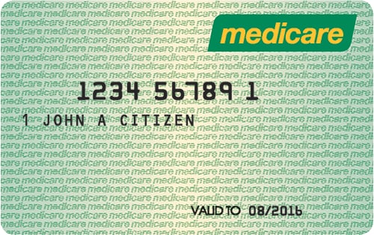 | We will ask you for your Medicare care number.
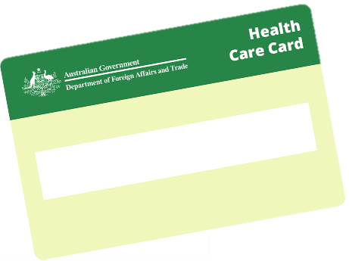 | We will ask you for your health care card number.
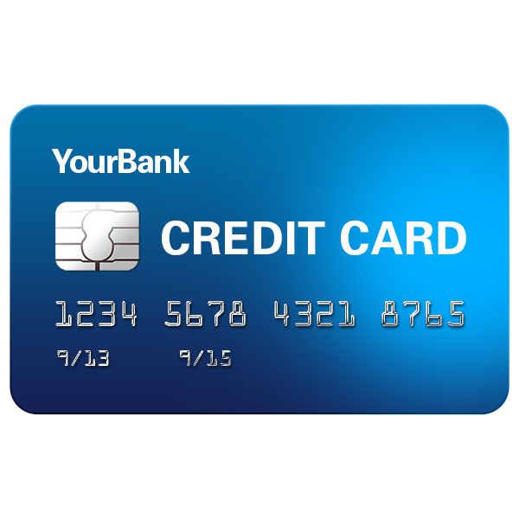 | We will ask you to tell us your [credit card number] over the phone.
 | From [name of person sending letter]

