Tailorable **How to get here** **Letter**

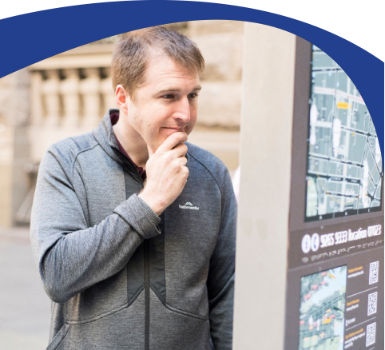

This Easy Read letter is a tool for health professionals and health   
administration staff to provide to people with intellectual disability and their supporters to support communication about directions to the appointment location.

# **How to use this Tailorable Easy Read How to get there Letter**

It is important to make sure the person understands what this letter says. Ask the person if they read Easy Read. Find out if they need support to read Easy Read. If they do, make sure you send the letter in time for them to show a support person.

* Insert relevant text where prompted. Text placeholders are marked in between brackets and in orange. E.g. [insert text here]. Delete all irrelevant text.
* Add the relevant images to accurately match each sentence. You can photograph the medication. Photos taken with a mobile phone are fine. We have added image placeholders. To replace a placeholder with a new image:
  1. Save the new image in your computer
  2. Right click on the placeholder
  3. Click on ‘Change Picture’
  4. 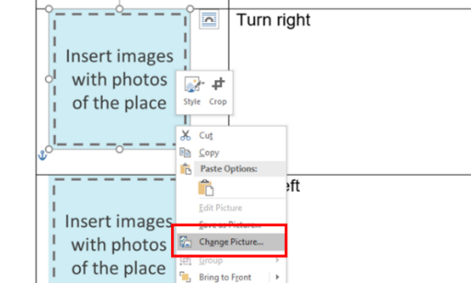Select the new image.
* Delete the rows you do not need (e.g. delete the ‘Nearest tram stop’ section if there are no trams nearby). To delete a row:
  1. Click the row you want to delete
  2. Right click and then click ‘Delete’
  3. 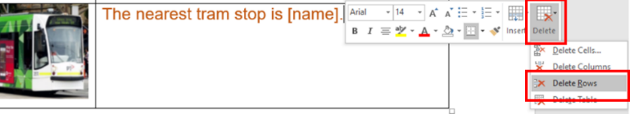Click ‘Delete Rows’.
* When you have finished tailoring the letter, change all font to black. Do this by selecting the table cells and choose font colour – black.
* Finally, remove the table lines. Do this by selecting the table cells then go to table design and select no border.
* Follow these principles when tailoring and formatting the letter to ensure it is Easy Read:
  + Nothing smaller than 14 point. Size 14 for main text and 16 or larger for headings.
  + Use Arial, Verdana or Tahoma (sans serif fonts).
  + Ensure plenty of white space. Include no more than four images per page.
  + Less is best, keep it simple:
    - Use short sentences and simple everyday words.
    - Avoid jargon and slang. If needing to use technical terms use **bold** and explain what the terms mean.
    - Avoid unnecessary details, focus on what people need to know, not what it is nice to know.

Note: All the images included in this document have been purchased through stock sites and Photosymbols and cannot be reproduced, redistributed or used for any other purpose without their permission. You need to ask CID if you want to use any of the pictures. Contact CID at [health@cid.org.au](mailto:health@cid.org.au).

Funded by the Department of Social Services.

**How to get to [insert name of health service].**

|  |  |
| --- | --- |
|  | The appointment is at [address].  [If a large building like a hospital or town centre, include level, and clinic name.] |
|  | The nearest bus stop is at [address].  [If possible add screenshot picture of real life bus stop from Google maps]. |
| Train | The nearest train station is [name of station].  [If possible add screenshot picture of real life train station from Google maps]. |
| C:\Users\pablo.nswcid\Downloads\Untitled design (64).png | The nearest light rail stop is at [address].  [If possible add screenshot picture of real life light trail stop from Google maps]. |
| Parking bay disabled | There is disability parking at [e.g. at our clinic; on the street outside; in the car park].  If you have a permit you can park in that spot. |
|  | You may be able to park on the street.  You **might be able** to park at [address].  Use actual street picture |
|  | Your parking will be free. |
| C:\Users\nicolea\OneDrive - NSW Council for Intellectual Disability\Pictures\Australian Cash Money.emf | Your parking will cost [Explain here if the person needs to pay for parking E.g. You have to pay if you stay longer than 3 hours.] |
| CarC:\Users\nicolea\AppData\Local\Microsoft\Windows\INetCache\Content.Word\Car Park Multi.png | You may be able to park in the car park.  There is a car park at [address].  [If possible add screenshot picture of real life car park from Google maps]. |
|  | Your parking will be free. |
| C:\Users\nicolea\OneDrive - NSW Council for Intellectual Disability\Pictures\Australian Cash Money.emf | Your parking will cost [Explain here if the person needs to pay for parking E.g. You have to pay if you stay longer than 3 hours.] |

**Once you arrive**

|  |  |
| --- | --- |
|  | The appointment is at [hospital or centre name].  [If a large building like a hospital or town centre, include level, and clinic name.]  This is what the building looks like. |
|  | Go in from [street name].  This is what the door looks like. |
|  | Talk to the people at the desk.  Tell them you need to get to [clinic name].  Tell them you have an appointment with [health worker name].  Ask if they can take you there. |
|  | You can show them this letter.  You can also show them your referral letter you got from [health professional name]. |
|  | Go to the end of the corridor. |
|  | Turn [insert instruction right or left]. |
|  | Take the lift to level [insert number E.g. 2]. |
|  | This is what our clinic door looks like. |
|  | This is what our clinic waiting room looks like. |
| Phone 1 Happy | If you have any questions about how to get here you can call [insert clinic number]. |
| C:\Users\NicoleAscaino\AppData\Local\Microsoft\Windows\INetCache\Content.MSO\DE62BC9F.tmp | You will see [health worker’s name].    [Health worker’s name] is a [insert role].    This is a picture of [health worker’s name]. |
| C:\Users\NicoleAscaino\AppData\Local\Microsoft\Windows\INetCache\Content.MSO\D6D90F05.tmp | It is at [time]. |
| C:\Users\NicoleAscaino\Downloads\Timer People 1 (1).png | This appointment will take [insert minutes or hours]. |