

Tailorable **Appointment** **Letter**

This Easy Read letter is a tool for health workers and health administration staff to support people with intellectual disability and their supporters to prepare before an appointment.



**How to use this Tailorable Easy Read Appointment Letter**

* It is important to make sure the person understands what this letter says. Ask the person if they read Easy Read. Find out if they need support to read Easy Read. If they do, make sure you send the letter in time for them to show a support person.
* Insert relevant text where prompted. Text placeholders and instructions are marked in between brackets and in orange. E.g. [insert text here].
* Delete the rows you do not need (e.g. delete the ‘Heart check’ section if the appointment is not for a heart check. To delete a row:
  + 1. Click the row you want to delete.
    2. Right click and then click ‘Delete’.
    3. 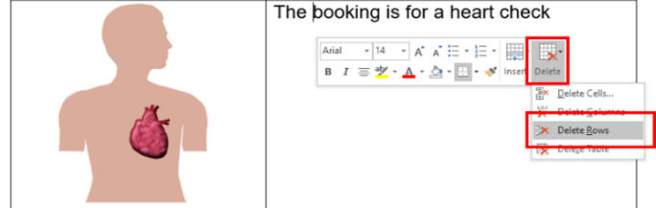Click ‘Delete Rows’.
* Add the relevant images to accurately match each sentence. You can photograph the building. Photos taken with a mobile phone are fine. We have added image placeholders. To replace a placeholder with a new image:
  1. Save the new image in your computer.
  2. Right click on the placeholder.
  3. Click on ‘Change Picture’.
  4. Select the new image.

**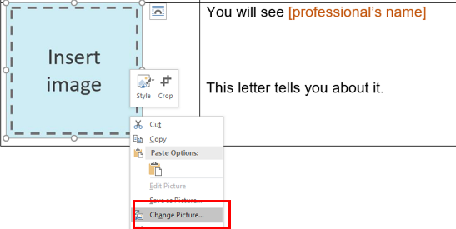**

* When you have finished tailoring the letter, change all font to black. Do this by selecting the table cells and choose font colour – black.
* Finally, remove the table lines. Do this by selecting the table cells then go to table design and select no border.
* Follow these principles when tailoring and formatting the letter to ensure it is Easy Read:
  + Nothing smaller than 14 point. Size 14 for main text and 16 or larger for headings.
  + Use Arial, Verdana or Tahoma (sans serif fonts).
  + Ensure plenty of white space. Include no more than four images per page.
  + Less is best, keep it simple:
    - Use short sentences and simple everyday words.
    - Avoid jargon and slang. If needing to use technical terms use **bold** and explain what the terms mean.
    - Avoid unnecessary details, focus on what people need to know, not what it is nice to know.

Note: All the images included in this document have been purchased through stock sites and Photosymbols and cannot be reproduced, redistributed or used for any other purpose without their permission. You need to ask CID if you want to use any of the pictures. Contact CID at [health@cid.org.au](mailto:health@cid.org.au)

Funded by the Department of Social Services.

|  |
| --- |
| **Easy Read Appointment Letter** |

|  |  |  |
| --- | --- | --- |
| C:\Users\lize\AppData\Local\Microsoft\Windows\INetCache\Content.MSO\EA89DB29.tmp | Dear [person’s name] | |
| **X**  **TYPE MONTH** | You have an appointment.  This letter tells you about it.  Your appointment is on [date in full]. | |
| xx : xx | It is at [time]. |
| C:\Users\lize\AppData\Local\Microsoft\Windows\INetCache\Content.MSO\EA89DB29.tmp | You will see [health worker’s name].  [Health worker’s name] is a [insert role].  This is a picture of [health worker’s name]. | |
| C:\Users\NicoleAscaino\Downloads\Timer People 1 (1).png | This appointment will take [insert minutes or hours]. | |
| Annual Health Check 1 | The appointment is for a health check. | |
| Ultrasound3 | The appointment is for an ultra sound.  That is kind of scan.  It will help to see what is going on. | |
| Heart 2 | The appointment is for a heart check. | |
| C:\Users\NicoleAscaino\AppData\Local\Microsoft\Windows\INetCache\Content.Word\Psychologist.png | The appointment is for **counselling.**  **Counselling** is when you talk to a counsellor about how you are feeling. | |
| Stomach Ache 2 | The appointment is to check your stomach. | |
| Medication Review | The appointment is to check your medicine. | |
| Choke Risk 3 | The appointment is to talk about healthy food. | |
| Vaccine Carer 2 | The appointment is for a vaccine. | |
| Optician eye test2 | The appointment is to check your eyes. | |
| Hearing test3 | The appointment is to check your ears. | |
|  | The appointment is for **occupational**  **therapy** to support you to do every day things.  **OT** for short. | |
| OT | The appointment is for **physiotherapy** to support you to move your body.  **Physio** for short. | |
|  | The appointment is to check on your teeth. | |
|  | The appointment is for speech therapy to support you to speak and eat. | |
|  | Your appointment is about [insert reason for appointment if not stated above]. | |
| Email Message | Your appointment is online on [day].  [Professional name] will email you a link.  It will be sent on [insert day before]. | |
|  | The appointment is at [insert address and level of clinic in hospital if relevant.]  This is what the building looks like. | |
| https://cdn.shopify.com/s/files/1/0606/1553/products/Write_diary_600x600.png?v=1417850743 | You can write down your appointment.  You can put it in your [phone calendar, in My Health Matters folder, in diary etc.] | |
| Question 5 | Do you have a question?  You can call [name or clinic or just me/us] on [number]. | |
| Phone 1 Happy | If you need to change the time of the appointment call [name or clinic or just me/us] on [number]. | |

**What to bring**

|  |  |
| --- | --- |
|  | Take these things to the appointment |
| Medicare card | Your Medicare card. |
| Concession Cards Fact Sheet - Financial Planning, Retirement Planning,  SMSF, Superannuation, Insurance - Mandurah, Rockingham, Pinjarra | Your Healthcare card. |
| C:\Users\nicolea\AppData\Local\Microsoft\Windows\INetCache\Content.Word\Medication Box (2).png | A list of the medicine you take. |
|  | Your health information.  Your My Health Matters Folder if you have one. |
| X ray | Your X-rays and scans. |
| T shirt | Wear a T-shirt with short sleeves.  You can have a jumper too. |
| C:\Users\nicolea\NSW Council for Intellectual Disability\CID Team Data - Health\Resources\Health Easy Read Resources\CID ER Factsheets to update\Updated ER Health Factsheets\Me and my doctor guide\Me and My doctor images\referral letter.jpg | The referral letter you got from [health professional name]. |
| C:\Users\lize\AppData\Local\Microsoft\Windows\INetCache\Content.MSO\EA89DB29.tmp | Thank you for reading this letter.  This letter is from [name of person sending letter]. |



Tailorable **Online Appointment Letter**

This Easy Read letter is a tool for health workers and health administration staff to support people with intellectual disability and their supporters to prepare before an online appointment.

**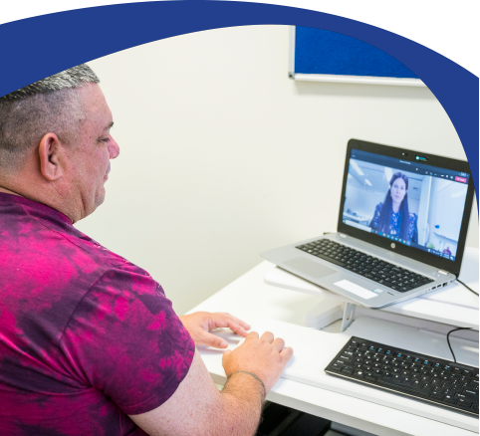**

**How to use this Tailorable Easy Read Online Appointment Letter**

* It is important to make sure the person understands what this letter says. Ask the person if they read Easy Read. Find out if they need support to read Easy Read. If they do, make sure you send the letter in time for them to show a support person.
* Insert relevant text where prompted. Text placeholders and instructions are marked in between brackets and in orange. E.g. [insert text here].
* Delete the rows you do not need (e.g. delete the ‘check your medicine’ section if the appointment is not for a medicine check. To delete a row:
  + 1. Click the row you want to delete.
    2. Right click and then click ‘Delete’.
    3. 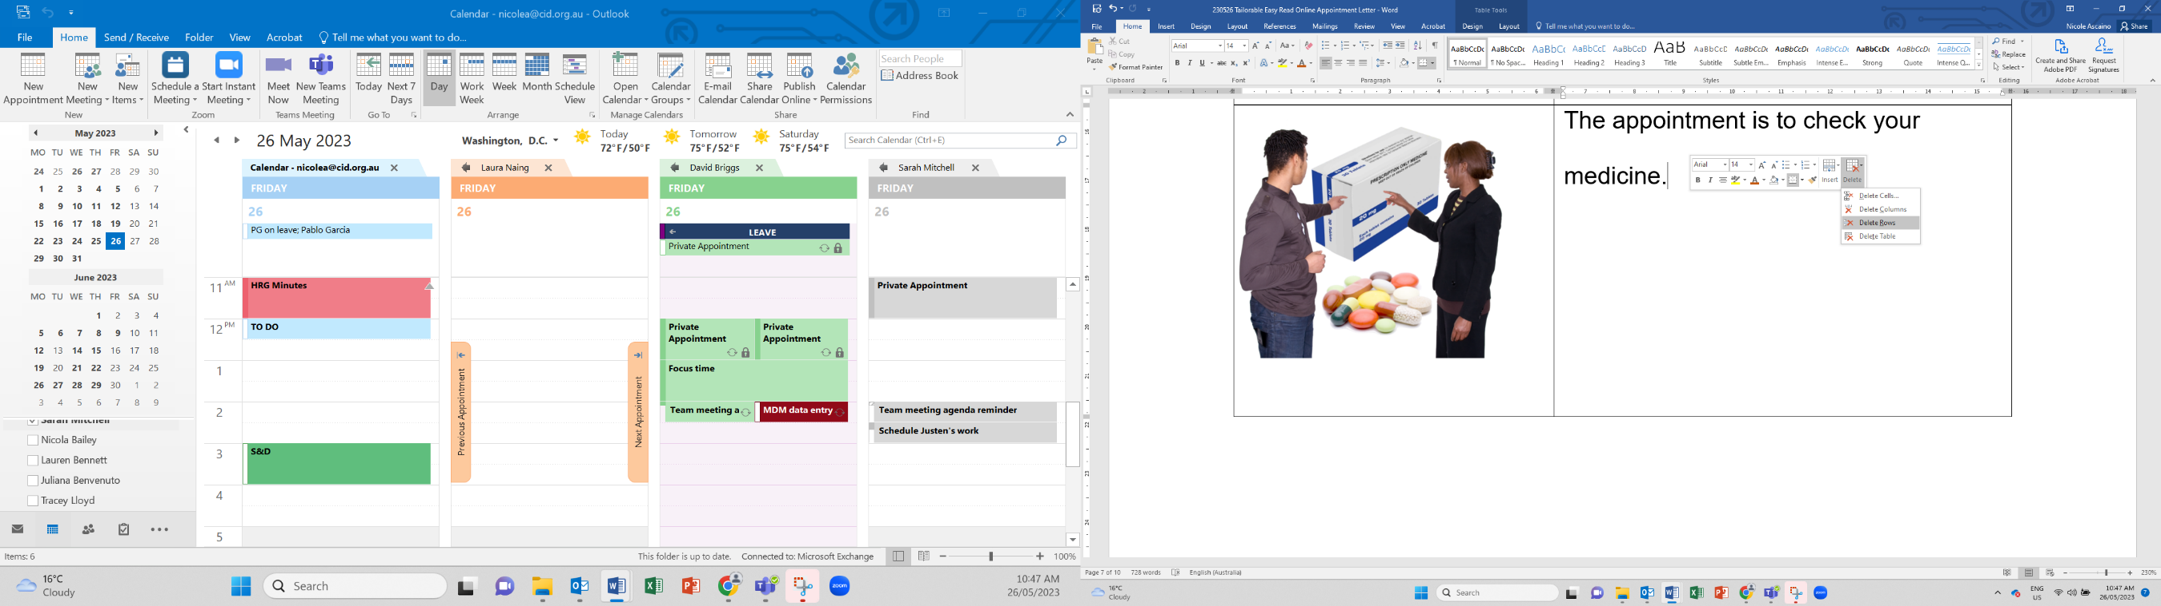Click ‘Delete Rows’.
* Add the relevant images to accurately match each sentence. You can photograph the building. Photos taken with a mobile phone are fine. We have added image placeholders. To replace a placeholder with a new image:
  1. Save the new image in your computer.
  2. Right click on the placeholder.
  3. Click on ‘Change Picture’.
  4. Select the new image.

**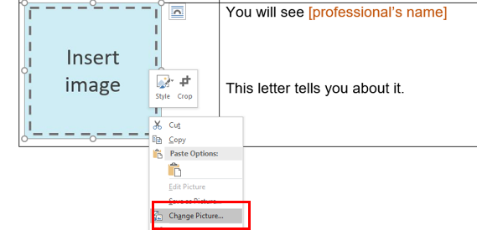**

* When you have finished tailoring the letter, change all font to black. Do this by selecting the table cells and choose font colour – black.
* Finally, remove the table lines. Do this by selecting the table cells then go to table design and select no border.
* Follow these principles when tailoring and formatting the letter to ensure it is Easy Read:
  + Nothing smaller than 14 point. Size 14 for main text and 16 or larger for headings.
  + Use Arial, Verdana or Tahoma (sans serif fonts).
  + Ensure plenty of white space. Include no more than four images per page.
  + Less is best, keep it simple:
    - Use short sentences and simple everyday words.
    - Avoid jargon and slang. If needing to use technical terms use **bold** and explain what the terms mean.
    - Avoid unnecessary details, focus on what people need to know, not what it is nice to know.

Note: All the images included in this document have been purchased through stock sites and Photosymbols and cannot be reproduced, redistributed or used for any other purpose without their permission. You need to ask CID if you want to use any of the pictures. Contact CID at [health@cid.org.au](mailto:health@cid.org.au).

Funded by the Department of Social Services.

|  |
| --- |
| **Easy Read Online Appointment Letter** |

|  |  |
| --- | --- |
| C:\Users\lize\AppData\Local\Microsoft\Windows\INetCache\Content.MSO\EA89DB29.tmp | Dear [person’s name] |
|  | You have an appointment.  This letter tells you about it. |
|  | Your appointment is online. |
|  | You will need a device for the appointment.  A device can be a   * computer * tablet   or   * phone. |
| **X**  **TYPE MONTH** | Your appointment is on [date in full]. |
| xx : xx | Your appointment is at [time]. |
| C:\Users\lize\AppData\Local\Microsoft\Windows\INetCache\Content.MSO\EA89DB29.tmp | You will see [health worker’s name].  [Health worker’s name] is a [insert role].  This is a picture of [health worker’s name]. |
| C:\Users\NicoleAscaino\Downloads\Timer People 1 (1).png | This appointment will take [insert minutes or hours]. |
| Email Message | [Health worker’s name] will send you an email.  It will include a   * Link * [User name * Password * Other] |
|  | When you click on the link you will see this page.  [Enter instructions. E.g. Enter user name and password.] |
| Free Microphone Icon, Symbol. PNG, SVG Download. | Make sure your microphone works. |
| C:\Users\angie\AppData\Local\Microsoft\Windows\INetCache\Content.MSO\25B78C19.tmp | Make sure your camera works. |
|  | If it does not work you can call [name or clinic or just me/us] on [number]. |
|  | The appointment is for a health check. |
| C:\Users\NicoleAscaino\AppData\Local\Microsoft\Windows\INetCache\Content.Word\Psychologist.png | The appointment is for **counselling.**  **Counselling** is when you talk to a counsellor about how you are feeling. |
| Medication Review | The appointment is to check your medicine. |
| Choke Risk 3 | The appointment is to talk about healthy food. |
|  | The appointment is for **occupational**  **therapy** to support you to do every day things.  **OT** for short. |
| OT | The appointment is for **physiotherapy** to support you to move your body. **Physio** for short. |
| SP | The appointment is for speech therapy to support you to speak and eat. |
|  | Your appointment is about [insert reason for appointment if not stated above]. |
| https://cdn.shopify.com/s/files/1/0606/1553/products/Write_diary_600x600.png?v=1417850743 | You can write down your appointment.  You can put it in your [phone calendar, in My Health Matters folder, in diary etc.] |
| Question 5 | Do you have a question?  You can call [name or clinic or just me/us] on [number]. |
| Phone 1 Happy | If you need to change the time of the appointment call [name or clinic or just me/us] on [number]. |
| C:\Users\lize\AppData\Local\Microsoft\Windows\INetCache\Content.MSO\EA89DB29.tmp | Thank you for reading this letter.  This letter is from [name of person sending letter]. |

Tailorable **How to get here** **Letter**

**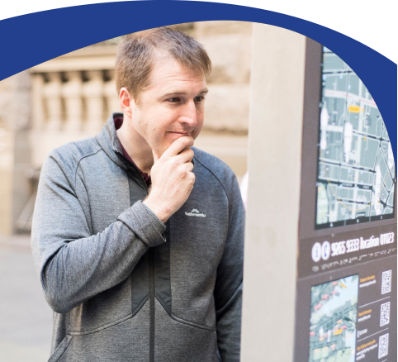**

This Easy Read letter is a tool for health professionals and health   
administration staff to provide to people with intellectual disability and their supporters to support communication about directions to the appointment location.

# **How to use this Tailorable Easy Read How to get there Letter**

It is important to make sure the person understands what this letter says. Ask the person if they read Easy Read. Find out if they need support to read Easy Read. If they do, make sure you send the letter in time for them to show a support person.

* Insert relevant text where prompted. Text placeholders are marked in between brackets and in orange. E.g. [insert text here]. Delete all irrelevant text.
* Add the relevant images to accurately match each sentence. You can photograph the medication. Photos taken with a mobile phone are fine. We have added image placeholders. To replace a placeholder with a new image:
  1. Save the new image in your computer
  2. Right click on the placeholder
  3. Click on ‘Change Picture’
  4. 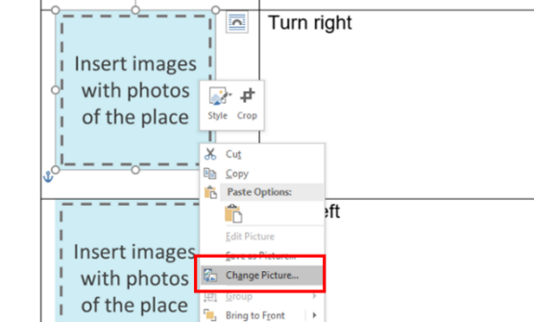Select the new image.
* Delete the rows you do not need (e.g. delete the ‘Nearest tram stop’ section if there are no trams nearby). To delete a row:
  1. Click the row you want to delete
  2. Right click and then click ‘Delete’
  3. 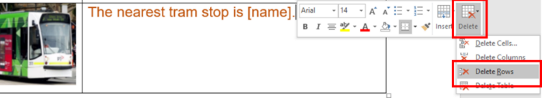Click ‘Delete Rows’.
* When you have finished tailoring the letter, change all font to black. Do this by selecting the table cells and choose font colour – black.
* Finally, remove the table lines. Do this by selecting the table cells then go to table design and select no border.
* Follow these principles when tailoring and formatting the letter to ensure it is Easy Read:
  + Nothing smaller than 14 point. Size 14 for main text and 16 or larger for headings.
  + Use Arial, Verdana or Tahoma (sans serif fonts).
  + Ensure plenty of white space. Include no more than four images per page.
  + Less is best, keep it simple:
    - Use short sentences and simple everyday words.
    - Avoid jargon and slang. If needing to use technical terms use **bold** and explain what the terms mean.
    - Avoid unnecessary details, focus on what people need to know, not what it is nice to know.

Note: All the images included in this document have been purchased through stock sites and Photosymbols and cannot be reproduced, redistributed or used for any other purpose without their permission. You need to ask CID if you want to use any of the pictures. Contact CID at [health@cid.org.au](mailto:health@cid.org.au).

Funded by the Department of Social Services.

**How to get to [insert name of health service].**

|  |  |
| --- | --- |
|  | The appointment is at [address].  [If a large building like a hospital or town centre, include level, and clinic name.] |
|  | The nearest bus stop is at [address].  [If possible add screenshot picture of real life bus stop from Google maps]. |
| Train | The nearest train station is [name of station].  [If possible add screenshot picture of real life train station from Google maps]. |
| C:\Users\pablo.nswcid\Downloads\Untitled design (64).png | The nearest light rail stop is at [address].  [If possible add screenshot picture of real life light trail stop from Google maps]. |
| Parking bay disabled | There is disability parking at [e.g. at our clinic; on the street outside; in the car park].  If you have a permit you can park in that spot. |
|  | You may be able to park on the street.  You **might be able** to park at [address].  Use actual street picture |
|  | Your parking will be free. |
| C:\Users\nicolea\OneDrive - NSW Council for Intellectual Disability\Pictures\Australian Cash Money.emf | Your parking will cost [Explain here if the person needs to pay for parking E.g. You have to pay if you stay longer than 3 hours.] |
| CarC:\Users\nicolea\AppData\Local\Microsoft\Windows\INetCache\Content.Word\Car Park Multi.png | You may be able to park in the car park.  There is a car park at [address].  [If possible add screenshot picture of real life car park from Google maps]. |
|  | Your parking will be free. |
| C:\Users\nicolea\OneDrive - NSW Council for Intellectual Disability\Pictures\Australian Cash Money.emf | Your parking will cost [Explain here if the person needs to pay for parking E.g. You have to pay if you stay longer than 3 hours.] |

**Once you arrive**

|  |  |
| --- | --- |
|  | The appointment is at [hospital or centre name].  [If a large building like a hospital or town centre, include level, and clinic name.]  This is what the building looks like. |
|  | Go in from [street name].  This is what the door looks like. |
|  | Talk to the people at the desk.  Tell them you need to get to [clinic name].  Tell them you have an appointment with [health worker name].  Ask if they can take you there. |
|  | You can show them this letter.  You can also show them your referral letter you got from [health professional name]. |
|  | Go to the end of the corridor. |
|  | Turn [insert instruction right or left]. |
|  | Take the lift to level [insert number E.g. 2]. |
|  | This is what our clinic door looks like. |
|  | This is what our clinic waiting room looks like. |
| Phone 1 Happy | If you have any questions about how to get here you can call [insert clinic number]. |
| C:\Users\NicoleAscaino\AppData\Local\Microsoft\Windows\INetCache\Content.MSO\DE62BC9F.tmp | You will see [health worker’s name].    [Health worker’s name] is a [insert role].    This is a picture of [health worker’s name]. |
| C:\Users\NicoleAscaino\AppData\Local\Microsoft\Windows\INetCache\Content.MSO\D6D90F05.tmp | It is at [time]. |
| C:\Users\NicoleAscaino\Downloads\Timer People 1 (1).png | This appointment will take [insert minutes or hours]. |



Tailorable **Medicine Letter**

This Easy Read letter is a tool for pharmacists, pharmacy support staff, General Practitioners and psychiatrists to provide medicine information to people with intellectual disability, and their supporters. Ultimately improving medication safety.

# 

# **How to use this Tailorable Easy Read Medicine Letter**

It is important to make sure the person understands what this letter says. Ask the person if they read Easy Read. Find out if they need support to read Easy Read. If they do, make sure you send the letter in time for the person to show a support person.

This letter is to be filled out each time the person is prescribed a new medication. To avoid confusion, the first 4 pages are to be used for a single medication, with the final page a complete list of the person's medication.

* Insert relevant text where prompted. Text placeholders are marked in between brackets and in orange. E.g. [insert text here].
* Delete the rows you do not need (e.g. delete the ‘New medicine brand’ section if the medicine brand is not new.) To delete a row:
  1. Click the row you want to delete.
  2. Right click and then click ‘Delete’.
  3. 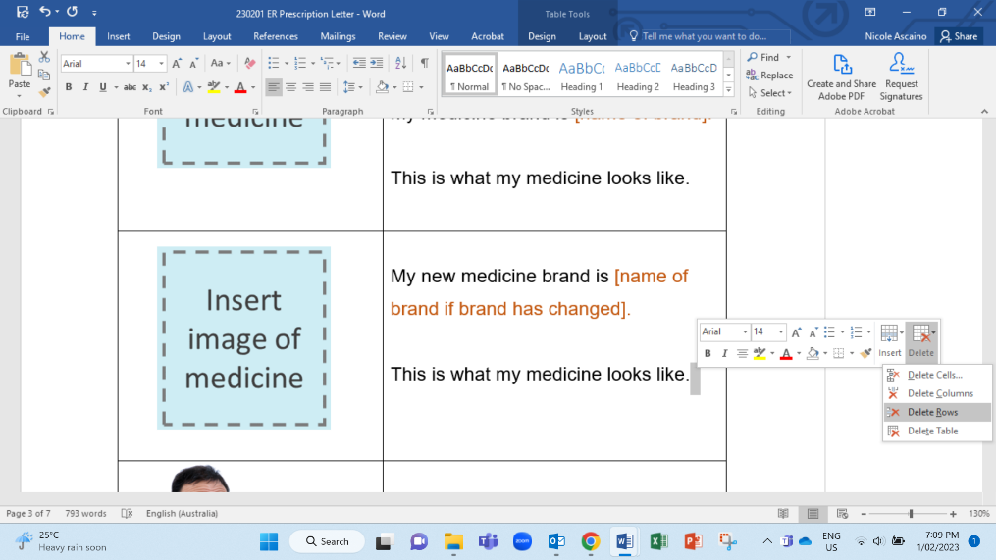Click ‘Delete Rows’.
* When you have finished tailoring the letter, change all font to black. Do this by selecting the table cells and choose font colour – black.
* Add relevant images to accurately match each sentence. Delete the irrelevant images. You can photograph the medication or find an image online. Photos taken with a mobile phone are fine. You can match the medicine name to an image of the actual medicine. We have added images you can replace. To replace a placeholder with a new image:

1. Save the new image in your computer.
2. Right click on the placeholder.
3. Click on ‘Change Picture’.
4. 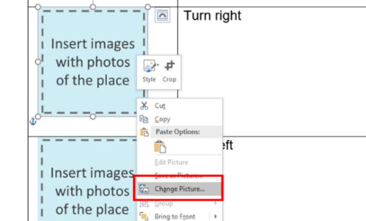Select the new image.

* Finally, remove the table lines. Do this by selecting the table cells then go to table design and select no border.
* Follow these principles when tailoring and formatting the letter to ensure it is Easy Read:
  + Nothing smaller than 14 point. Size 14 for text and 16 or larger for headings.
  + Use Arial, Verdana or Tahoma (sans serif fonts).
  + Ensure plenty of white space. Include no more than four images per page.
  + Less is best, keep it simple:
    - Use short sentences and simple everyday words.
    - Avoid jargon and slang. If needing to use technical terms use **bold** and explain what the terms mean.
    - Avoid unnecessary details, focus on what people need to know, not what it is nice to know.

We suggest sending a completed copy of this letter to the person's health professionals (Eg. their pharmacist or GP) as a way to enhance communication about medication.

Note: All the images included in this document have been purchased through stock sites and Photosymbols and cannot be reproduced, redistributed or used for any other purpose without their permission. You need to ask CID if you want to use any of the pictures. Contact CID at [health@cid.org.au](mailto:health@cid.org.au).

Funded by the Department of Social Services.

**My Medicine**

|  |  |
| --- | --- |
|  | My medicine is [name of active ingredient here].  My medicine brand is [name of brand].  This is what my medicine looks like. |
|  | My new medicine brand is [name of brand if brand has changed].  This is the same medicine as [previous brand name].  This is what my medicine looks like. |
| C:\Users\nicolea\AppData\Local\Microsoft\Windows\INetCache\Content.Word\Medication Read (2).png | My medicine will help me with [insert what medicine has been prescribed for. Use bullet points if more than one]. |
| C:\Users\nicolea\AppData\Local\Microsoft\Windows\INetCache\Content.Word\Medication Box (2).png | **Side effects** are issues that might happen after taking medicine.  **Side effects** of my medicine might be like [insert possible side effects of this medicine. Use bullet points if more than one. E.g.   * Confused * Fast heart beat]. |
| Feel sick (2)C:\Users\nicolea\AppData\Local\Microsoft\Windows\INetCache\Content.Word\Health Action Plan 1 (1).png | If these side effects happen to me I should?  [Insert advice for person if the side effects do occur. Do they have to call the ambulance? Should they call NSW Poison Information Line on 13 11 26? Do they have to call their doctor immediately? Is it a common side effect and something to keep monitoring? Use bullet points]. |
| C:\Users\nicolea\AppData\Local\Microsoft\Windows\INetCache\Content.Word\Medication 2 (1).png | How much medicine do I take?  [Insert dosage in numbers E.g. 2 tablets each day, or 1 tablet 2 times each day.]. |
| C:\Users\nicolea\AppData\Local\Microsoft\Windows\INetCache\Content.Word\Night (1).pngC:\Users\nicolea\AppData\Local\Microsoft\Windows\INetCache\Content.Word\Day (1).pngC:\Users\nicolea\AppData\Local\Microsoft\Windows\INetCache\Content.Word\Days (3).png | When do I take my medicine?  [Insert clear details of when E.g. in the morning and at night, or 2 hours after food]. |
| C:\Users\nicolea\AppData\Local\Microsoft\Windows\INetCache\Content.Word\Self Medication 1.pngC:\Users\nicolea\AppData\Local\Microsoft\Windows\INetCache\Content.Word\Peg Feed Tube.png | How do I take my medicine?  [Describe method of delivery, if able to swallow tablet, take through feeding tube, if needing to take with food.] |
| C:\Users\nicolea\AppData\Local\Microsoft\Windows\INetCache\Content.Word\Fridge.pngC:\Users\nicolea\AppData\Local\Microsoft\Windows\INetCache\Content.Word\Cupboard or fridge.png | Where do I store my medicine?  [Insert location of storage like cupboard or fridge.] |
| C:\Users\nicolea\AppData\Local\Microsoft\Windows\INetCache\Content.Word\When_ (1).png | When do I **not** take my medicine?  [Insert warnings and use by date here]. |
| C:\Users\nicolea\AppData\Local\Microsoft\Windows\INetCache\Content.Word\Forget.pngC:\Users\nicolea\AppData\Local\Microsoft\Windows\INetCache\Content.Word\Health Action Plan 1 (1).png | What should I do if I do not take my medicine?  Like if I forgot to take it or if I do not have it with me.  [Insert advice for person if they do not take the medicine. Who can they ask for more information? Do they have to call their doctor or chemist? Do they have to take two tablets the next day instead? Use bullet points]. |
| C:\Users\nicolea\AppData\Local\Microsoft\Windows\INetCache\Content.Word\Medication Box (2).png  C:\Users\nicolea\AppData\Local\Microsoft\Windows\INetCache\Content.Word\Medicine (1).png | [Review both options below and take out the sentences that are not relevant].  My other medications have not changed.  I must keep taking them.  [Or]  My other medicines have changed. [Insert advice about any changes in other medicine use in bullet points]. |

**List of my medicines**

|  |  |
| --- | --- |
| C:\Users\nicolea\AppData\Local\Microsoft\Windows\INetCache\Content.Word\Medication Box (2).png  C:\Users\nicolea\AppData\Local\Microsoft\Windows\INetCache\Content.Word\Medicine (1).pngC:\Users\nicolea\AppData\Local\Microsoft\Windows\INetCache\Content.Word\Tablets.png | The medicines I take are      Please write a list here of the names of all the medicine a person currently needs to take using bullet points. Add images of each medicine in the left column. This is an optional section.  This list is for the person to be clear if they can continue to take their regular medication with their new medication.  If this person would like a list of all their current medicines   * Ask if the person lives in a group home that provide an Easy Read medicine chart. * Advise the person to contact their pharmacist and GP. * If time allows support the person by contacting their different pharmacies to find out their other medications. |



Tailorable **Referral Letter**

This Easy Read letter is for health workers and health administration staff to explain details of a referral to people with intellectual disability and their supporters.

**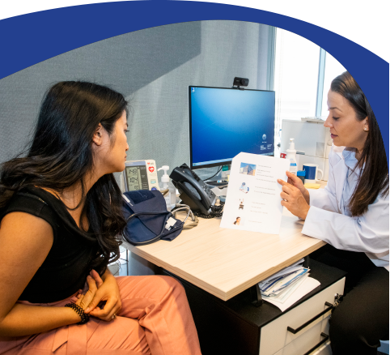**

**How to use this Tailorable Easy Read Referral Letter**

It is important to make sure the person understands what this letter says. Ask the person if they read Easy Read. Find out if they need support to read Easy Read. If they do, make sure you send the letter in time for them to show a support person.

* Insert relevant text where prompted. Text placeholders and instructions are marked in between brackets and in orange. E.g. [insert text here]. Delete all irrelevant text.
* Delete the rows you do not need. E.g. delete the ‘Heart check’ section if the appointment is not for a heart check.

To delete a row:

* + 1. Click the row you want to delete.
    2. Right click and then click ‘Delete’.
    3. Click ‘Delete Rows’.

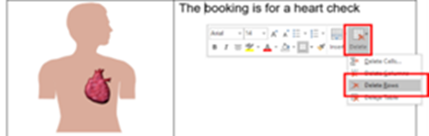

* When you have finished tailoring the letter, change all font to black. Do this by selecting the table cells and choose font colour – black.
* Add the relevant images to accurately match each sentence. You can photograph the building or find an image online. Photos taken with a mobile phone are fine. We have added image placeholders. To replace a placeholder with a new image:
  1. Save the new image in your computer.
  2. Right click on the placeholder.
  3. Click on ‘Change Picture’.
  4. Select the new image.

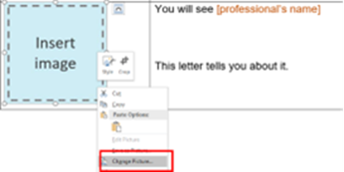

* Finally, remove the table lines. Do this by selecting the table cells then go to table design and select no border.
* Follow these principles when tailoring and formatting the letter to ensure it is Easy Read:
  + Nothing smaller than 14 point. Size 14 for main text and 16 or larger for headings.
  + Use Arial, Verdana or Tahoma (sans serif fonts).
  + Ensure plenty of white space. Include no more than four images per page.
  + Less is best, keep it simple:
    - Use short sentences and simple everyday words.
    - Avoid jargon and slang. If needing to use technical terms use **bold** and explain what the terms mean.
    - Avoid unnecessary details, focus on what people need to know, not what it is nice to know.

Note: All the images included in this document have been purchased through stock sites and Photosymbols and cannot be reproduced, redistributed or used for any other purpose without their permission. You need to ask CID if you want to use any of the pictures. Contact CID at [health@cid.org.au](mailto:health@cid.org.au).

Funded by the Department of Social Services.

**Easy Read Referral Letter**

|  |  |
| --- | --- |
| C:\Users\lize\AppData\Local\Microsoft\Windows\INetCache\Content.MSO\EA89DB29.tmp | Dear [patient name] |
|  | This is your **referral letter**.  A **referral** **letter** says you need to see a different health worker.    It also says why you need to see them. |
| C:\Users\lize\AppData\Local\Microsoft\Windows\INetCache\Content.MSO\EA89DB29.tmp | This referral letter is to see [insert name of health worker].  [Health worker’s name] is a [insert role].  This is a picture of [health worker’s name]. |
|  | This referral letter is to see a doctor.  The doctor will talk to you about [reason for referral]. |
| C:\Users\nicolea\AppData\Local\Microsoft\Windows\INetCache\Content.Word\Dentist.jpg | This referral letter is to see a **dentist**.  A dentist checks your teeth. |
|  | This referral letter is to see a **speech therapist.**  A speech therapist supports you to speak and eat. |
| C:\Users\NicoleAscaino\AppData\Local\Microsoft\Windows\INetCache\Content.Word\Psychologist.jpg | This referral letter is to see a **psychologist**.  A **psychologist** supports your mental health.  You can talk to a **psychologist** about how you are feeling. |
| Medication Review | This referral letter is to see a **psychiatrist**.  A **psychiatrist** supports you with medicine for your mental health. |
|  | This referral letter is to see a **physiotherapist.** **Physio** for short.  A **physio** supports you to move your body. |
|  | This referral letter is to see a **occupational** **therapist**. **OT** for short.  An **OT** supports you to do your everyday things. |
| Choke Risk 3 | This referral letter is to see a **dietitian**.  A dietitian talks to you about healthy food. |
| Optician eye test2 | This referral letter is to see an **optometrist**.  An optometrist checks your eyes. |
| Hearing test3 | This referral letter is to see an ear specialist. |
| Ultrasound3 | This referral letter is to get an **ultrasound.**  An **ultrasound** is a kind of scan.  It will help to see what is going on. |
| Heart 2 | This referral letter is for a heart check. |
| Stomach Ache 2 | This referral letter is to check your stomach. |
| C:\Users\lize\AppData\Local\Microsoft\Windows\INetCache\Content.MSO\EA89DB29.tmp | You need this referral letter because [insert reasons for referral.] |
| Phone 1 Happy | You can call [insert name of health worker referred to] on [insert number]. |
| C:\Users\nicolea\AppData\Local\Microsoft\Windows\INetCache\Content.Word\Medication Read (1).png  C:\Users\NicoleAscaino\Downloads\When_ (2).png | You can talk about   * Your health and sickness if you are sick * Your medicine * Booking an appointment |
| C:\Users\NicoleAscaino\Downloads\Doctor Phone 1.png | It is OK if you need support during the call.  You can ask the receptionist for support to book an appointment. |
| C:\Users\NicoleAscaino\AppData\Local\Microsoft\Windows\INetCache\Content.MSO\51B00598.tmp | Thank you for reading this letter.  This letter is from [name of person sending letter]. |
| Question 5 | If you have any questions you can call [name of person sending letter] on [insert number.] |
| **X**  **TYPE MONTH** | This referral letter was sent on [insert date]. |



Tailorable **Ideas Form**

This tailorable Easy Read ideas form is for health service staff to use with people with intellectual disability and their supporters. It is an accessible way for the person to reflect on the health service and provide feedback.



**How to use this Tailorable Easy Read Ideas Form**

* It is important to make sure the person understands what this form says. Ask the person if they read Easy Read. Find out if they need support to read Easy Read. If they do, make sure you send the letter in time for them to show a support person.
* Insert relevant text where prompted. Text placeholders and instructions are marked in between brackets and in orange. E.g. [insert text here].
* When you have finished tailoring the letter, change all font to black. Do this by selecting the table cells and choose font colour – black.
* Finally, remove the table lines. Do this by selecting the table cells then go to table design and select no border.
* Follow these principles when tailoring and formatting the letter to ensure it is Easy Read:
  + Nothing smaller than 14 point. Size 14 for main text and 16 or larger for headings.
  + Use Arial, Verdana or Tahoma (sans serif fonts).
  + Ensure plenty of white space. Include no more than four images per page.
  + Less is best, keep it simple:
    - Use short sentences and simple everyday words.
    - Avoid jargon and slang. If needing to use technical terms use **bold** and explain what the terms mean.
    - Avoid unnecessary details, focus on what people need to know, not what it is nice to know.

Note: All the images included in this document have been purchased through stock sites and Photosymbols and cannot be reproduced, redistributed or used for any other purpose without their permission. You need to ask CID if you want to use any of the pictures. Contact CID at [health@cid.org](mailto:health@cid.org).

Funded by the Department of Social Services.

|  |  |
| --- | --- |
| **Easy Read Ideas Form** | |
| C:\Users\NicoleAscaino\Downloads\Group 53 (1).png | You can help us make [name of service] better.  We want to hear your ideas. |
| C:\Users\NicoleAscaino\Downloads\Tick Yes (1).pngC:\Users\NicoleAscaino\Downloads\Writing (1).png  C:\Users\NicoleAscaino\Downloads\Thumb up (1).png  C:\Users\NicoleAscaino\Downloads\Dont know man1 (1).pngC:\Users\NicoleAscaino\Downloads\Thumb down (1).png | For this part you can tick the box that is right for you.  Would you tell other people to come to [name of service]?   * Yes * No * Unsure |
| C:\Users\NicoleAscaino\Downloads\Fill form together1 (1).pngGP FriendlyC:\Users\NicoleAscaino\Downloads\Writing (1).png | For this part you can write your answer.  It is OK if you need support to write your answer.  How can we make this service better? |
| C:\Users\NicoleAscaino\Downloads\Phone 1 Upset.png | If you did not get good health care.  You can make a **complaint**.  A **complaint** means speaking up when you are not happy. |
|  | You can read the CID fact sheet called **Your right to good health care** for tips on making complaints.  You can see the factsheet here  [www.cid.org.au/your-right-to-good-health-care-fact-sheet/](http://www.cid.org.au/your-right-to-good-health-care-fact-sheet/) |
| C:\Users\NicoleAscaino\Downloads\Thank You 1.png | Thank you for your ideas. |



Tailorable **Ideas Form**

This tailorable Easy Read ideas form is for health service staff to use with people with intellectual disability and their supporters. It is an accessible way for the person to reflect on the health service and provide feedback.



**How to use this Tailorable Easy Read Ideas Form**

* It is important to make sure the person understands what this form says. Ask the person if they read Easy Read. Find out if they need support to read Easy Read. If they do, make sure you send the letter in time for them to show a support person.
* Insert relevant text where prompted. Text placeholders and instructions are marked in between brackets and in orange. E.g. [insert text here].
* When you have finished tailoring the letter, change all font to black. Do this by selecting the table cells and choose font colour – black.
* Finally, remove the table lines. Do this by selecting the table cells then go to table design and select no border.
* Follow these principles when tailoring and formatting the letter to ensure it is Easy Read:
  + Nothing smaller than 14 point. Size 14 for main text and 16 or larger for headings.
  + Use Arial, Verdana or Tahoma (sans serif fonts).
  + Ensure plenty of white space. Include no more than four images per page.
  + Less is best, keep it simple:
    - Use short sentences and simple everyday words.
    - Avoid jargon and slang. If needing to use technical terms use **bold** and explain what the terms mean.
    - Avoid unnecessary details, focus on what people need to know, not what it is nice to know.

Note: All the images included in this document have been purchased through stock sites and Photosymbols and cannot be reproduced, redistributed or used for any other purpose without their permission. You need to ask CID if you want to use any of the pictures. Contact CID at [health@cid.org](mailto:health@cid.org).

Funded by the Department of Social Services.

|  |  |
| --- | --- |
| **Easy Read Ideas Form** | |
| C:\Users\NicoleAscaino\Downloads\Group 53 (1).png | You can help us make [name of service] better.  We want to hear your ideas. |
| C:\Users\NicoleAscaino\Downloads\Tick Yes (1).pngC:\Users\NicoleAscaino\Downloads\Writing (1).png  C:\Users\NicoleAscaino\Downloads\Thumb up (1).png  C:\Users\NicoleAscaino\Downloads\Dont know man1 (1).pngC:\Users\NicoleAscaino\Downloads\Thumb down (1).png | For this part you can tick the box that is right for you.  Would you tell other people to come to [name of service]?   * Yes * No * Unsure |
| C:\Users\NicoleAscaino\Downloads\Fill form together1 (1).pngGP FriendlyC:\Users\NicoleAscaino\Downloads\Writing (1).png | For this part you can write your answer.  It is OK if you need support to write your answer.  How can we make this service better? |
| C:\Users\NicoleAscaino\Downloads\Phone 1 Upset.png | If you did not get good health care.  You can make a **complaint**.  A **complaint** means speaking up when you are not happy. |
|  | You can read the CID fact sheet called **Your right to good health care** for tips on making complaints.  You can see the factsheet here  [www.cid.org.au/your-right-to-good-health-care-fact-sheet/](http://www.cid.org.au/your-right-to-good-health-care-fact-sheet/) |
| C:\Users\NicoleAscaino\Downloads\Thank You 1.png | Thank you for your ideas. |



Tailorable **Ideas Form for Online Appointments**

****

This tailorable Easy Read ideas form is for health service staff to use with people with intellectual disability and their supporters.   
It is an accessible way for the person to reflect on the online health service and provide feedback.

|  |  |
| --- | --- |
| **Easy Read Ideas Form for Online Appointments** | |
| C:\Users\NicoleAscaino\Downloads\Group 53 (1).png | You can help us make the [service] better.  We want to hear your ideas. |
| C:\Users\NicoleAscaino\Downloads\Tick Yes (1).png  C:\Users\NicoleAscaino\Downloads\Thumb up (1).png  C:\Users\NicoleAscaino\Downloads\Dont know man1 (1).pngC:\Users\NicoleAscaino\Downloads\Thumb down (1).png | For this part you can tick the box that is right for you.  Would you tell other people to book to this online service?   * Yes * No * Unsure |
| C:\Users\NicoleAscaino\Downloads\Annual Report photo shoot - Photo credit Council for Intellectual Disability - 7.jpgC:\Users\NicoleAscaino\Downloads\Jack and Fiona work on computer - Photo credit Council for Intellectual Disability - 7.jpgC:\Users\NicoleAscaino\Downloads\Online Appointment Letter.jpg | For this part you can type your answer.  It is OK if you need support to type your answer.  How can we make this online service better? |
| C:\Users\NicoleAscaino\Downloads\Phone 1 Upset.png | If you did not get good health care.  You can make a **complaint**.  A **complaint** means speaking up when you are not happy. |
|  | You can read the CID fact sheet called **Your right to good health care** for tips on making complaints.  You can see the fact sheet here  [www.cid.org.au/your-right-to-good-health-care-fact-sheet/](http://www.cid.org.au/your-right-to-good-health-care-fact-sheet/) |
| C:\Users\NicoleAscaino\Downloads\Thank You 1.png | Thank you for your ideas. |

Funded by the Department of Social Services.