

Tailorable **Medicine Letter**

This Easy Read letter is a tool for pharmacists, pharmacy support staff, General Practitioners and psychiatrists to provide medicine information to people with intellectual disability, and their supporters. Ultimately improving medication safety.

# 

# **How to use this Tailorable Easy Read Medicine Letter**

It is important to make sure the person understands what this letter says. Ask the person if they read Easy Read. Find out if they need support to read Easy Read. If they do, make sure you send the letter in time for the person to show a support person.

This letter is to be filled out each time the person is prescribed a new medication. To avoid confusion, the first 4 pages are to be used for a single medication, with the final page a complete list of the person's medication.

* Insert relevant text where prompted. Text placeholders are marked in between brackets and in orange. E.g. [insert text here].
* Delete the rows you do not need (e.g. delete the ‘New medicine brand’ section if the medicine brand is not new.) To delete a row:
  1. Click the row you want to delete.
  2. Right click and then click ‘Delete’.
  3. 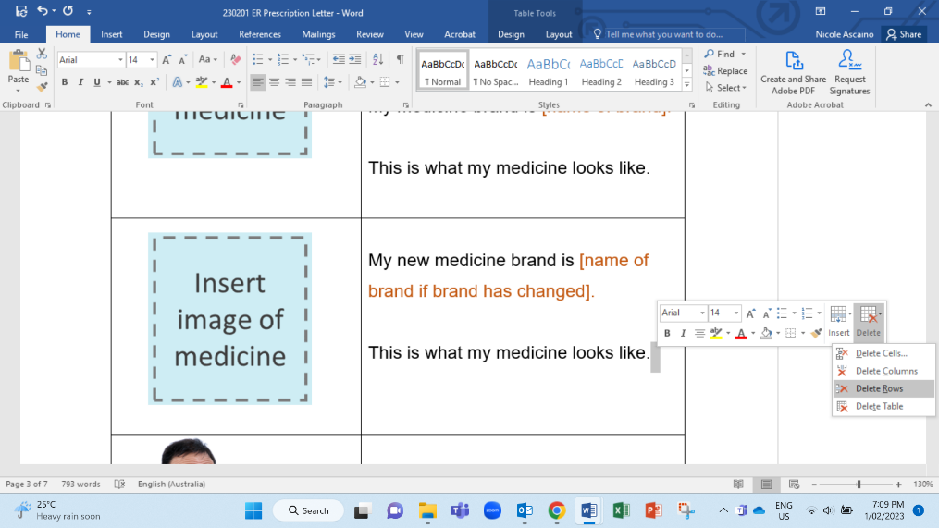Click ‘Delete Rows’.
* When you have finished tailoring the letter, change all font to black. Do this by selecting the table cells and choose font colour – black.
* Add relevant images to accurately match each sentence. Delete the irrelevant images. You can photograph the medication or find an image online. Photos taken with a mobile phone are fine. You can match the medicine name to an image of the actual medicine. We have added images you can replace. To replace a placeholder with a new image:

1. Save the new image in your computer.
2. Right click on the placeholder.
3. Click on ‘Change Picture’.
4. 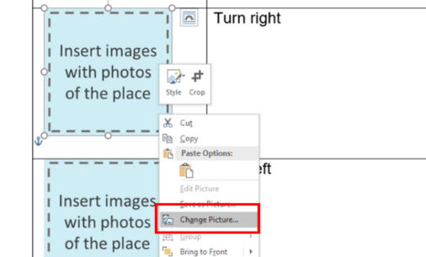Select the new image.

* Finally, remove the table lines. Do this by selecting the table cells then go to table design and select no border.
* Follow these principles when tailoring and formatting the letter to ensure it is Easy Read:
  + Nothing smaller than 14 point. Size 14 for text and 16 or larger for headings.
  + Use Arial, Verdana or Tahoma (sans serif fonts).
  + Ensure plenty of white space. Include no more than four images per page.
  + Less is best, keep it simple:
    - Use short sentences and simple everyday words.
    - Avoid jargon and slang. If needing to use technical terms use **bold** and explain what the terms mean.
    - Avoid unnecessary details, focus on what people need to know, not what it is nice to know.

We suggest sending a completed copy of this letter to the person's health professionals (Eg. their pharmacist or GP) as a way to enhance communication about medication.

Note: All the images included in this document have been purchased through stock sites and Photosymbols and cannot be reproduced, redistributed or used for any other purpose without their permission. You need to ask CID if you want to use any of the pictures. Contact CID at [health@cid.org.au](mailto:health@cid.org.au).

Funded by the Department of Social Services.

**My Medicine**

|  |  |
| --- | --- |
|  | My medicine is [name of active ingredient here].  My medicine brand is [name of brand].  This is what my medicine looks like. |
|  | My new medicine brand is [name of brand if brand has changed].  This is the same medicine as [previous brand name].  This is what my medicine looks like. |
| C:\Users\nicolea\AppData\Local\Microsoft\Windows\INetCache\Content.Word\Medication Read (2).png | My medicine will help me with [insert what medicine has been prescribed for. Use bullet points if more than one]. |
| C:\Users\nicolea\AppData\Local\Microsoft\Windows\INetCache\Content.Word\Medication Box (2).png | **Side effects** are issues that might happen after taking medicine.  **Side effects** of my medicine might be like [insert possible side effects of this medicine. Use bullet points if more than one. E.g.   * Confused * Fast heart beat]. |
| Feel sick (2)C:\Users\nicolea\AppData\Local\Microsoft\Windows\INetCache\Content.Word\Health Action Plan 1 (1).png | If these side effects happen to me I should?  [Insert advice for person if the side effects do occur. Do they have to call the ambulance? Should they call NSW Poison Information Line on 13 11 26? Do they have to call their doctor immediately? Is it a common side effect and something to keep monitoring? Use bullet points]. |
| C:\Users\nicolea\AppData\Local\Microsoft\Windows\INetCache\Content.Word\Medication 2 (1).png | How much medicine do I take?  [Insert dosage in numbers E.g. 2 tablets each day, or 1 tablet 2 times each day.]. |
| C:\Users\nicolea\AppData\Local\Microsoft\Windows\INetCache\Content.Word\Night (1).pngC:\Users\nicolea\AppData\Local\Microsoft\Windows\INetCache\Content.Word\Day (1).pngC:\Users\nicolea\AppData\Local\Microsoft\Windows\INetCache\Content.Word\Days (3).png | When do I take my medicine?  [Insert clear details of when E.g. in the morning and at night, or 2 hours after food]. |
| C:\Users\nicolea\AppData\Local\Microsoft\Windows\INetCache\Content.Word\Self Medication 1.pngC:\Users\nicolea\AppData\Local\Microsoft\Windows\INetCache\Content.Word\Peg Feed Tube.png | How do I take my medicine?  [Describe method of delivery, if able to swallow tablet, take through feeding tube, if needing to take with food.] |
| C:\Users\nicolea\AppData\Local\Microsoft\Windows\INetCache\Content.Word\Fridge.pngC:\Users\nicolea\AppData\Local\Microsoft\Windows\INetCache\Content.Word\Cupboard or fridge.png | Where do I store my medicine?  [Insert location of storage like cupboard or fridge.] |
| C:\Users\nicolea\AppData\Local\Microsoft\Windows\INetCache\Content.Word\When_ (1).png | When do I **not** take my medicine?  [Insert warnings and use by date here]. |
| C:\Users\nicolea\AppData\Local\Microsoft\Windows\INetCache\Content.Word\Forget.pngC:\Users\nicolea\AppData\Local\Microsoft\Windows\INetCache\Content.Word\Health Action Plan 1 (1).png | What should I do if I do not take my medicine?  Like if I forgot to take it or if I do not have it with me.  [Insert advice for person if they do not take the medicine. Who can they ask for more information? Do they have to call their doctor or chemist? Do they have to take two tablets the next day instead? Use bullet points]. |
| C:\Users\nicolea\AppData\Local\Microsoft\Windows\INetCache\Content.Word\Medication Box (2).png  C:\Users\nicolea\AppData\Local\Microsoft\Windows\INetCache\Content.Word\Medicine (1).png | [Review both options below and take out the sentences that are not relevant].  My other medications have not changed.  I must keep taking them.  [Or]  My other medicines have changed. [Insert advice about any changes in other medicine use in bullet points]. |

**List of my medicines**

|  |  |
| --- | --- |
| C:\Users\nicolea\AppData\Local\Microsoft\Windows\INetCache\Content.Word\Medication Box (2).png  C:\Users\nicolea\AppData\Local\Microsoft\Windows\INetCache\Content.Word\Medicine (1).pngC:\Users\nicolea\AppData\Local\Microsoft\Windows\INetCache\Content.Word\Tablets.png | The medicines I take are      Please write a list here of the names of all the medicine a person currently needs to take using bullet points. Add images of each medicine in the left column. This is an optional section.  This list is for the person to be clear if they can continue to take their regular medication with their new medication.  If this person would like a list of all their current medicines   * Ask if the person lives in a group home that provide an Easy Read medicine chart. * Advise the person to contact their pharmacist and GP. * If time allows support the person by contacting their different pharmacies to find out their other medications. |