

Tailorable **Online Appointment Letter**

This Easy Read letter is a tool for health workers and health administration staff to support people with intellectual disability and their supporters to prepare before an online appointment.

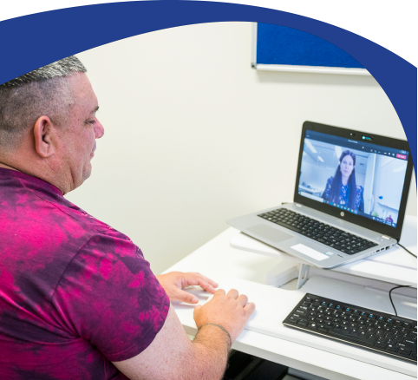

**How to use this Tailorable Easy Read Online Appointment Letter**

* It is important to make sure the person understands what this letter says. Ask the person if they read Easy Read. Find out if they need support to read Easy Read. If they do, make sure you send the letter in time for them to show a support person.
* Insert relevant text where prompted. Text placeholders and instructions are marked in between brackets and in orange. E.g. [insert text here].
* Delete the rows you do not need (e.g. delete the ‘check your medicine’ section if the appointment is not for a medicine check. To delete a row:
  + - Click the row you want to delete.
    - Right click and then click ‘Delete’.
    - 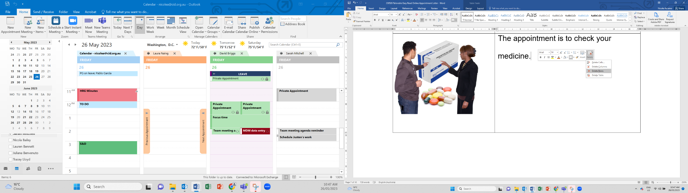Click ‘Delete Rows’.
* Add the relevant images to accurately match each sentence. You can photograph the building. Photos taken with a mobile phone are fine. We have added image placeholders. To replace a placeholder with a new image:
  1. Save the new image in your computer.
  2. Right click on the placeholder.
  3. Click on ‘Change Picture’.
  4. Select the new image.

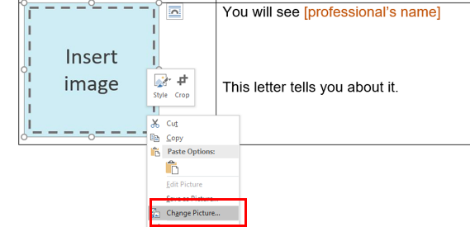

* When you have finished tailoring the letter, change all font to black. Do this by selecting the table cells and choose font colour – black.
* Finally, remove the table lines. Do this by selecting the table cells then go to table design and select no border.
* Follow these principles when tailoring and formatting the letter to ensure it is Easy Read:
  + Nothing smaller than 14 point. Size 14 for main text and 16 or larger for headings.
  + Use Arial, Verdana or Tahoma (sans serif fonts).
  + Ensure plenty of white space. Include no more than four images per page.
  + Less is best, keep it simple:
    - Use short sentences and simple everyday words.
    - Avoid jargon and slang. If needing to use technical terms use **bold** and explain what the terms mean.
    - Avoid unnecessary details, focus on what people need to know, not what it is nice to know.

Note: All the images included in this document have been purchased through stock sites and Photosymbols and cannot be reproduced, redistributed or used for any other purpose without their permission. You need to ask CID if you want to use any of the pictures. Contact CID at [health@cid.org.au](mailto:health@cid.org.au).

Funded by the Department of Social Services.

|  |
| --- |
| **Easy Read Online Appointment Letter** |

|  |  |
| --- | --- |
| C:\Users\lize\AppData\Local\Microsoft\Windows\INetCache\Content.MSO\EA89DB29.tmp | Dear [person’s name] |
|  | You have an appointment.  This letter tells you about it. |
|  | Your appointment is online. |
|  | You will need a device for the appointment.  A device can be a   * computer * tablet   or   * phone. |
| **X**  **TYPE MONTH** | Your appointment is on [date in full]. |
| xx : xx | Your appointment is at [time]. |
| C:\Users\lize\AppData\Local\Microsoft\Windows\INetCache\Content.MSO\EA89DB29.tmp | You will see [health worker’s name].  [Health worker’s name] is a [insert role].  This is a picture of [health worker’s name]. |
| C:\Users\NicoleAscaino\Downloads\Timer People 1 (1).png | This appointment will take [insert minutes or hours]. |
| Email Message | [Health worker’s name] will send you an email.  It will include a   * Link * [User name * Password * Other] |
|  | When you click on the link you will see this page.  [Enter instructions. E.g. Enter user name and password.] |
| Free Microphone Icon, Symbol. PNG, SVG Download. | Make sure your microphone works. |
| C:\Users\angie\AppData\Local\Microsoft\Windows\INetCache\Content.MSO\25B78C19.tmp | Make sure your camera works. |
|  | If it does not work you can call [name or clinic or just me/us] on [number]. |
|  | The appointment is for a health check. |
| C:\Users\NicoleAscaino\AppData\Local\Microsoft\Windows\INetCache\Content.Word\Psychologist.png | The appointment is for **counselling.**  **Counselling** is when you talk to a counsellor about how you are feeling. |
| Medication Review | The appointment is to check your medicine. |
| Choke Risk 3 | The appointment is to talk about healthy food. |
|  | The appointment is for **occupational**  **therapy** to support you to do every day things.  **OT** for short. |
| OT | The appointment is for **physiotherapy** to support you to move your body. **Physio** for short. |
| SP | The appointment is for speech therapy to support you to speak and eat. |
|  | Your appointment is about [insert reason for appointment if not stated above]. |
| https://cdn.shopify.com/s/files/1/0606/1553/products/Write_diary_600x600.png?v=1417850743 | You can write down your appointment.  You can put it in your [phone calendar, in My Health Matters folder, in diary etc.] |
| Question 5 | Do you have a question?  You can call [name or clinic or just me/us] on [number]. |
| Phone 1 Happy | If you need to change the time of the appointment call [name or clinic or just me/us] on [number]. |
| C:\Users\lize\AppData\Local\Microsoft\Windows\INetCache\Content.MSO\EA89DB29.tmp | Thank you for reading this letter.  This letter is from [name of person sending letter]. |